Technical Guide: Topographic Vegetation Analysis using Landsat 8/9 and ASTER GDEM
Author: James McLoughlin
Date: May 2026
Repository: [Link to your GitHub Repository]

1. Introduction
This code e package provides an automated pipeline for monitoring vegetation health across complex topographic gradients. By integrating multispectral Landsat 8/9 imagery with ASTER Global Digital Elevation Models (GDEM), the code quantifies the relationship between elevation and vegetation vigor using the Normalized Difference Vegetation Index (NDVI). The tool is designed for conservation managers and researchers to identify how altitudinal shifts influence biomass and ecosystem health in protected areas.

1. Introduction
This code provides automated spatial analysis, quantifying the relationship between vegetation health and topographic elevation. It combines multispectral Landsat 8/9 imagery with ASTER Global Digital Elevation Models (GDEM) to enable the assement of vengration stress as a function of elevtation. monitoring of the tool enables researchers to monitor environmental stress and biomass productivity across varying altitudes.
The primary function of the code is to segment a study area into discrete elevation zones (e.g., 500m intervals) and perform Zonal Statistics to calculate the Normalized Difference Vegetation Index (NDVI) for each zone. This spatiotemporal approach is vital for understanding how climate change and altitudinal lapse rates influence ecosystem vigor in protected areas like National Parks.

2. Setup and Installation
2.1 System Requirements & Dependencies
The scripts in this repository were developed using Jupyter, as such a package and environment management system like Conda (Miniconda/Anaconda) is recommended for their execution. The preferred IDEs are either PyCharm or JupyterLab/Notebook.
The following dependencies are required:
- Python 3.11 or later: Required by NASA’s earthaccess library, which is accessed by the scripts.
- Geospatial Analysis: geopandas, rasterio, rasterstats, shapely.
- Data Handling: xarray, rioxarray, numpy, pandas, notebook.
- Analysis & Visualization: matplotlib, scipy, matplotlib-scalebar.
- Data Acquisition: earthaccess.

  - Installation Steps
- Repository: Clone the GitHub Repository, which contains all the necessary scripts and test data to run the code:
https://github.com/jjmcloughlin05/EGM722-Assessment
- Environment Setup: The .yml file in the repository includes a list of the necessary dependencies.
- NASA EarthAccess Authorization: The code utilizes data from the NASA earthaccess library. To access the online library, you must have an Earthdata account. Once registered, create a .netrc file in your home directory with the login credential in the following format:
‘machine urs.earthdata.nasa.gov login <username> password <password>’

2.3 Directory Structure
The code operated on a predefined directory structure to facilitate file management, sorting of different file types, and for any potential debugging (Figure 1)
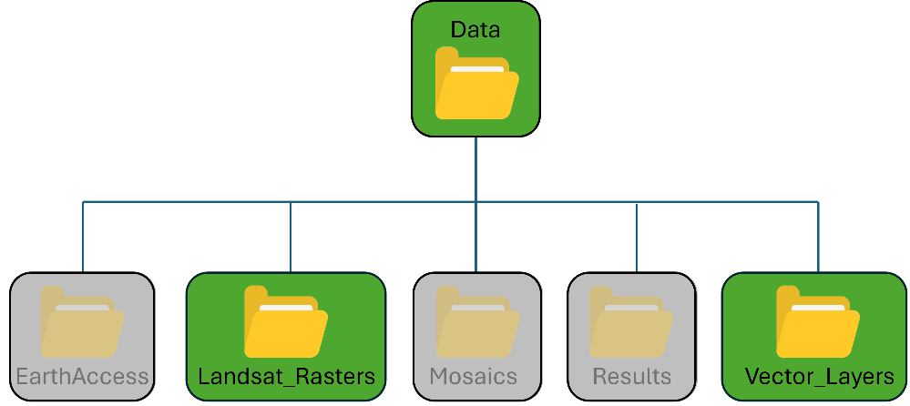
The required directory setup varies upon the previous setup actions taken:
- Full Repository Cloned: If the full repository was cloned, the necessary directory structure is already configured. The only action is to provide the scripts with the file path for the parent <Data> directory (discussed later).
- Manual Setup: If building the directory structure from scratch, manually create the directories indicated in green. Directories in grey are generated automatically during runtime.
  - Note: The name and location of the main Data directory can be changed, but all subdirectory must have the names and structure shown in figure 1 exactly. Once constructed the path of parent <Data> directory needs to be entered into the scripts (discussed later).

  - Sample Data
The workflow utilizes Landsat imagery, vector files, and Digital Elevation Models (DEMs). The repository includes all necessary sample files to execute the code, but if they need to be resourced details for their acquisition are provided below:
- Landsat Images: The script processes Landsat Level-2 Surface Reflectance data. The code does not include cloud-masking routines so images with 0% cloud cover are highly recommended.
  - Data: The sample files used for the study (sourced via USGS EarthExplorer):
    - LC09_L2SP_037035_20250627_20250628_02_T1
    - LC09_L2SP_038035_20250704_20250705_02_T1
  - Storage: Place all files in <Data>/Landsat_Rasters. The code scans all subfolders automatically so manual sorting is not needed.
  - Format: Files must retain the NASA Landsat naming conventions. To conserve disk space all files except those ending in SR_B*.TIF can be discarded.

- Vector File: A shapefile is used to define the study area (region of interest - ROI). This optimises memory usage by clipping rasters before processing and provides spatial filtering when for earthaccess library searches.
  - Data: The study uses the Grand Canyon National Park boundary from ArcGIS online. [ref].
  - Storage: The shapefile is to be located and named as follows:
<Data>/Vector_Layers/national_park_boundary.shp
  - Format: The file must be in .shp format. If downloaded as an ArcGIS Pro Potral file (.pitemx) it needs to be converted to a .shp file first. This can be achieved by loading then exporting the layer in ArcGIS Pro or QIS.
- Digital Elevation Models (DEM): The code automatically downloads DEM tiles from earthaccess so no action is needed.

3 Methodology
The repository contains two scripts:
- Data_processing.ipyb: processes the raw rasters, DEMs, and vector data, and performes the spatial analysis
- Data_presenting.ipyb: Visualizes the results of the analysis in the form of maps and scatter plots.
This following sections describes the operation and functions involved in each script.

3.1 Data Processing
3.1.1 Path Configuration – Required to Run Script!
Before running the script, the user must map the path of the <Data> directory in the script. This is done the ‘Base Folder Configuration’ section of the code (immediately after the module imports). To run the script as standard no further actions need to be done.

3.1.2 Landsat Spectral Colour
The code starts by creating a list of spectral colours required for the desired analysis and display tasks.
In the downloaded version these are set to conduct NDVI analysis and create true- and false-colour composites. If other index analyses or composites are desired these can be added in section 2 ‘Tasks and Spectral Bands’. The titles of the tasks should be added to the either the ‘DISPLAY_TASKS’ or ‘ANALYSIS_TASKS’ tuples and the colours added to the TASK_BANDS dictionary. Note that the names should match the formatting and the order of the colours in TASK_BANDS is important.

3.1.3 Data Cataloging
A DataFrame of the Landsat files needed for the selected tasks is then created. This is achieved by iterating through all the Landsat data files and extracting the satellite identifier (e.g. LT07, LC09) and band identifier (e.g., B4, B5) from the filenames. These identifiers are used to determine the spectral colour of the file (e.g., Red, NIR), which is checked against the list of required colours to determine whether the file is needed.

3.1.4 Mosaicking
The study area spans multiple satellite scenes so mosaicking is performed to avoid errors that can occur when analysing data across un-joined rasters. The code groups the catalogued files by colour and the uses rasterio.merge [ref] to create a mosaic of each colour band.

3.1.5 Spatiochromatic Data Stacking
The mosaics of the colour bands are compiled into a multi-dimensional xarray Dataset. This allows for the complex cross-band processes (such as NDVI analysis and composite image creation) to be achieved with relative ease compared to processing the mosaics individually. The is complimented by Dask-backed chunking to enable "Lazy Loading" and reduce the risk of memory saturation [2].

3.1.6 Normalised Difference Index Calculation
The Normalized Difference Vegetation Index is computed from the dataset using the general index formula (equation 1):
$$\begin{aligned}NDI= \frac{Band_1-Band_2}{Band_1+Band_2} \#\left(1\right)\end{aligned}$$

where Band_1 and Band_ represent different spectral bands, and for NDVI calculations Band_1 = NIR and Band_2 = Red. These specific bands are used because they utilize the unique spectral signature of chlorophyll, which strongly absorbs red light but highly reflects Near-Infrared (NIR) light. Values typically range from -1 to 1, with higher values indicate denser, healthier biomass.
The script uses this generalised form of the equation to allow the simple inclusion of other index calculations (e.g. Normalized Difference Water Index (NDWI) or the Normalized Difference Snow Index (NDSI)).

3.1.7 Topographic Acquisition and Vectorisation
The study utilises DEMs to provide an elevation map of the area, which is the other critical component needed when assessing NDVI as a function of height.
The DEMs are acquired automatically from the online NASA earthaccess library where a bounding box, derived from park boundary polygon, is used select only DEMs that spatially overlap the study area. For the study ASTER Global Digital Elevation Models (GDEM) V3 data is used. The suitable DEM files are then mosaicked into a single image using the same mosaicking process discussed above.
The mosaicked DEM is then vectorised into polygons relating to regions of defined elevation ranges. This is achieved by diving the DEM mosaic by a defined step size (in this case 500m) and utilizing floor division to ensure every pixel falls into a specific elevation range. rasterio.features.shapes [ref] is then used polygonise the classified DEM into elevation zones.

3.1.9 Zonal Analysis
Here the elevation polygons generated from the DEM are then combined with the NDVI to generate the spatial analysis desired from this study. The ‘zonal_stats’ function within the rasterstats library [ref] is used to calculate the mean NDVI and standard deviation within each polygon, and all data is stored in a GeoPackage (.gpkg) to allow for future analysis [4].

3.1.10 Composite creation
Finally true- and false- colour composites are created from the band mosicas. While these are only used for display purposes it is easiest to create them in this script using the xarray dataset.

3.2 Data Presenting
The datapresenting.ipyb script used the composite images, DEM mosaic, and spatial statistics generated by the data_processing.ipyb script to present the analysis results through maps and graphs.

3.2.1 User Settings
Similar to the data_processing.ipyb script, the user must map the path of the <Data> directory to allow this script to locate the data to display. In addition the user has the option of displaying either the true- or false colour composite, overlaid with either the average NDVI data or the elevation zone data.
This file mapping and display options are set in the "User Configuration" section of the script, immediately below the module imports.

3.2.2 Map Preparation and Display
After reading in the selected composite image it is immediately clipped to a predefined region to optimize memory usage. In this case the region is defined using a 10km buffer around the park shapefile’s bounding box. The image contrast is then refined using percentile clipping (in this case 5% to 99%) and the brightness adjust with gamma scaling (g = 0.8). Finally, the clipped image is downsampled to further reduce demands on memory.
To visualise the terrain the DEM mosaic is read-in and xarray-spatial [ref] used to generate a hillshade. A Gaussian filter (s = 3) is then applied to the hillshade to remove the high frequency noise and smooth the profile.
Finally the park boundary and elevation zones are added to the map alongside the chosen data layer (elevation zone values or mean NDVI).

3.2.3 Graph Preparation and Display
For the data plots, the elevation and NDVI statistics are extracted from the .gpkg file. The data is processed to calculate the mean NDVI per elevation (rather than per polygon) and plotted in a "Mean NDVI vs. Elevation" scatter plot.

4. Expected Results
The successful execution of the analysis and visualization scripts produces the following spatial and graphical outputs.
4.1 Integrated Geospatial Database (GeoPackage)
The vectorized elevation polygons and the respective NDVI statistics (mean and standard deviation) generated by the data_processing script are saved as a GeoPackage (.gpkg) to the location:
<Data>/Results/elevation_zones_with_stats_2025.gpkg
The .gpkg format was selected to prove a self-contained "ready-to-use" GIS layer compatible with other software packages for further mapping or analysis.
4.2 Cartographic Visualization
The data_presenting script generates a map of the area overlayed with the results of spatial analysis. An example of an output is shown in figure 2:
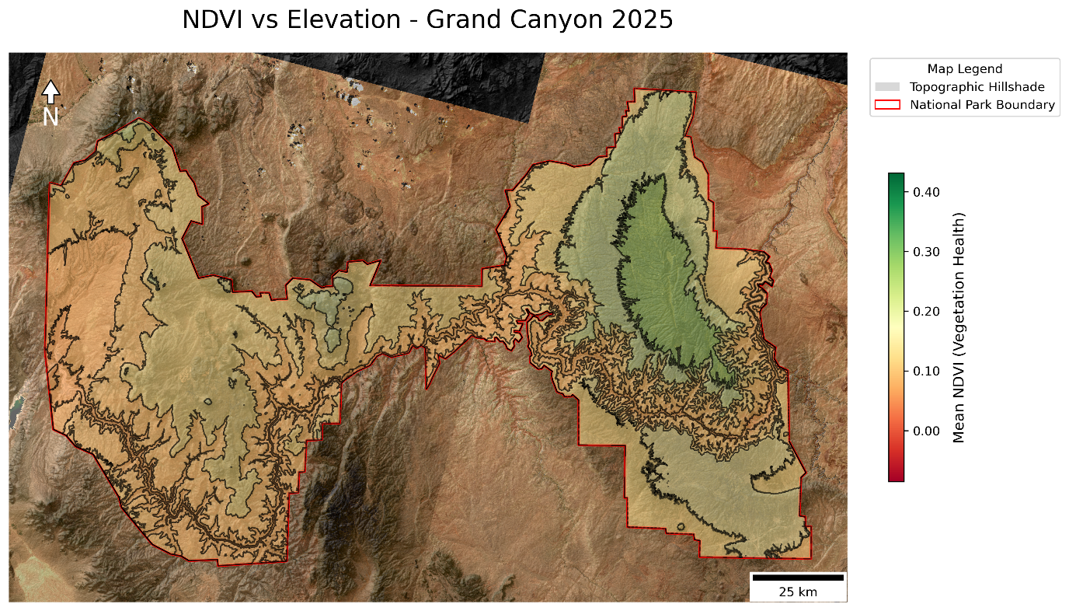
Figure 2: Example map generated by the script. The image shows a true-colour composite of the region, enhanced with a hillshade, along with the study region perimeter (red line), elevations zone boundaries (black lines), and the mean NDVI per region.
Depending upon the user’s choice the output figure contains:
- Composite Layer: either a true-colour composite or false-colour composite.
- Hillshade: A smoothed topographic layer illustrating relief.
- Segmented Overlay: Color coded regions corresponding to either the mean vegetation health (NDVI) or elevation ranges.
- Cartographic Elements: A scale bar, north arrow, and legend.
The images are saved to <Data>/Results directory using the following naming convention:
<composite_type>_<data_type>_MAP_<year>.png

4.3 Statistical Elevation Profile
The data_presenting script also generates a scatter plot illustrating mean NDVI as a function of elevation, as illustrated in figure 3:
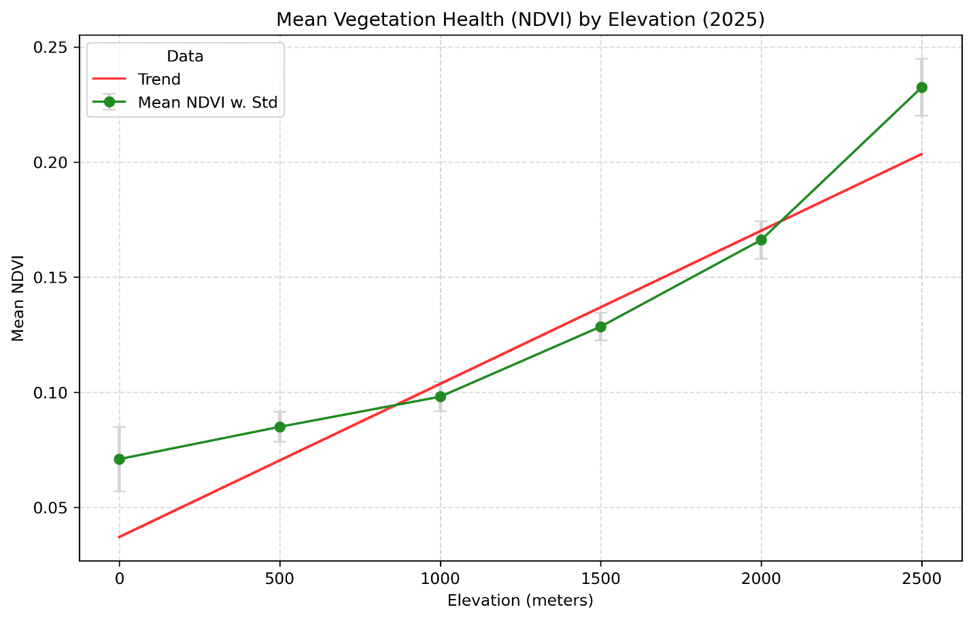
Figure 3: Scatter plot showing the mean NDVI and standard deviation per elevation step (green), along with a first-order polynomial fit (red).

The scatter plot includes:
- Data Points with Error Bars: Data points represent the average NDVI at each elevation step while the error bars indicate the standard deviation (spread) of the data.
- Linear Trendline: A first-order polynomial fit characterising the overall relationship between vegetation health and elevation within the study area.

5. Troubleshooting
Below are errors that may be encountered and steps to resolve them.
- DataSourceError: C:\...\...: No such file or directory
  - Cause: A specific file or directory is missing from your local machine, is misspelt, or is in the wrong sub-directory.
  - Fix: Identify the missing filename or directory from the error message. Refer to Sections 2.3 and 2.4 to verify the correct location and naming of the problem directory/file and correct accordingly.
- KeyError: 'year'
  - Cause: The script is attempting to process an empty folder or cannot find the expected Landsat files.
  - Fix: Ensure the <Data> path is entered correctly in the script and the Landsat_Rasters folder is named exactly as specified. Verify that the folder contains the necessary .tif files.
- MemoryError: Unable to assign xx Mb/Gb to memory
  - Cause: The raster data is too large for your system's available RAM.
  - Fix:
    - In the data_processing script: Reduce the chunk size in Section 5 of the code.
    - In the data_presenting script: Reduce the image resolution by increasing the x and y values in the coarsening function at the end of Section 2.
- LoginAttemptFailure: Authentication with Earthdata Login failed
  - Cause: Incorrect NASA Earthdata credentials or a malformed search geometry.
  - Fix:
    - Double-check your username and password in the .netrc file.
- Empty Map/Overlay
  - Cause: CRS Mismatch between the data being combined (either: rasters, ROI shapefile, DEMs, elevation opolygons)
  - Fix: Ensure the CRS match for all components being considered. Reproject any misaligned layers using .to_crs(<img>.rio.crs).

6. References
National park boundary :
https://www.arcgis.com/home/item.html?id=707bfbd056d044dcac5b39f59c665647

- Hoyer, S. & Hamman, J. (2017). xarray: N-D labeled arrays and datasets in Python. Journal of Open Research Software. [DOI: 10.5334/jors.148]
- Hunter, J. D. (2007). Matplotlib: A 2D graphics environment. Computing in Science & Engineering.
- McKinney, W. (2010). Data Structures for Statistical Computing in Python. Proceedings of the 9th Python in Science Conference.
- USGS (2025). Landsat 8-9 Calibration and Validation. [Online] Available at: usgs.gov
- Wulder, M. A., et al. (2019). Current status of Landsat program, science, and applications. Remote Sensing of Environment.
- Casas, A., et al. (2017). Comparison of open-source GIS software for spatial data management.

